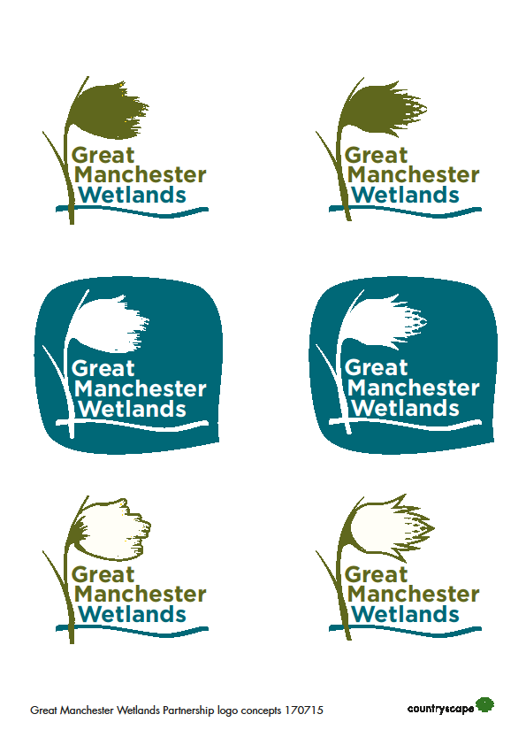

**Great Manchester Wetlands Nature Improvement Area PARTNERSHIP TERMS OF REFERENCE**

1. **Scope**

Great Manchester Wetlands Partnership is the supporting body for the Great Manchester Wetlands Nature Improvement Area (NIA). The NIA was locally determined by the Greater Manchester and Cheshire Local Nature Partnerships in 2013. A map showing the boundary of the Great Manchester Wetlands geographic area can be found in Annex 1.

1. **Purpose**

The Great Manchester Wetlands Partnership exists to work together to progress the objectives and aims of the Great Manchester Wetlands NIA (sometimes referred to as GMW).

Our vision is that:

*By 2025 Great Manchester Wetlands will be a thriving, resilient and inspirational landscape that delivers real benefits to local communities and the local economy*

Our detailed objectives are:

1: To mitigate the impact of environmental pressures by improving species mobility between Lancashire, Cheshire and Greater Manchester.

2: To make a lasting improvement to some of Britain’s rarest habitats by restoring key designated sites (SAC, SSSI, LNR) and priority BAP habitats.

3: To improve regional and local connectivity for critical species by creating stepping stones and corridors between habitats and populations.

4: To optimise the ecosystem services provided by all habitats particularly the carbon storage function of lowland raised bog.

5: Continue to build and deliver a shared vision for nature recovery in the wider landscape with key partners, organisations and local people.

6. Enhance community health, wellbeing, learning and skills through improved access to nature and creative engagement with the landscape

1. **Membership**

Membership of the Partnership is open to relevant local authorities, statutory bodies, businesses, NGOs, charities, community groups, academic institutions or other bodies who are willing and able to commit to and contribute to the long term aims and development of the Partnership. A lead partner will be assigned to be responsible for Partnership coordination. Non-members may be invited to meetings from time to time.

A current list of organisations involved can be found in Annex 2.

1. **Coordinator**

The Partnership will be supported, when funding is available, by a Coordinator role, hosted by the Lead Partner, who will organise meetings, share information, support the website and other communications and maintain the strategic plan.

1. **Member commitments**

Members commit to:

* Meeting on a quarterly basis
* Sharing relevant information and knowledge with others in the partnership
* Promoting GMW in their own work and communications
* Taking into account the aims of GMW in policies, strategies, plans and projects
* Supporting joint funding bids and delivery projects
* Influencing others to support the delivery of GMW’s aims
* Working and communicating with each other effectively and cooperatively

1. **Methods of working/means of contributing**

Members of the partnership will work together collaboratively in the spirit of mutual support to deliver improvements. Ways in which members can contribute more widely to GMW include:

* + using strategic influence to support GMW
  + communicating GMW activities more widely
  + helping steer the long-term strategy and direction and ensuring GMW responds to changes
  + identifying opportunities and threats
  + providing information and direction for work streams
  + undertaking research and applying latest techniques/tools
  + sharing specialist knowledge or the benefit of experience
  + providing advice
  + disseminating best practice
  + ensuring work adheres to relevant standards and guidelines
  + taking an overview of delivery work to ensure it is integrated
  + monitoring and recording outputs.

**Annex 1: Where do we operate?**

The Great Manchester Wetlands Partnership represents a landscape-scale community and natural heritage project of some 48,000 hectares. It focusses on the wetlands within and around Wigan (The Flashes), the mosslands in and around Salford and Warrington (The Mosslands) and the Mersey corridor stretching from Rixton to Warrington, including the Woolston Eyes SSSI (The Mersey Wetlands Corridor). The area extends south-eastwards beyond the Manchester Ship Canal encompassing parts of Trafford and northwards to include a substantial corridor which is the watershed area between the Mersey and the River Douglas catchments.



**Annex 2: Organisations involved:**

NGOs/Charities/Community Groups

* Canal and River Trust
* Cheshire Wildlife Trust
* City of Trees
* Lancashire Wildlife Trust **(Lead Partner)**
* Mersey Rivers Trust
* RSPB
* The Conservation Volunteers
* Woolston Eyes Conservation Group

Local Authorities

* Greater Manchester Ecology Unit
* Salford City Council
* Trafford Council
* Warrington Borough Council
* Wigan Council

Statutory Organisations

* Environment Agency
* Forestry Commission
* Natural England

Businesses

* Peel Land and Property Group
* United Utilities

Academic Institutions

* Edge Hill University
* University of Liverpool
* University of Manchester
* Manchester Metropolitan University
* University of Salford

Other non-partner organisations may be involved in specific delivery projects.