FAQs
WHERE IS THE HIVE?
The Hive is behind the Cafe on Moss Bank Park, towards the northern end. The area circled at the top is The Hive, just above the Cafe.
IS THERE PARKING?
Moss Bank Park has plenty of parking provision and parking is free across the site. On fine days the park can be very busy so please allow a little bit more time to get parked up on these days especially for the 2pm party slots. We would suggest that your guests use the Southern car park which is located at the main entrance. It is a five-minute walk through the park to get to the Hive from this location.
UNLOADING/LOADING
The red arrow shows a small parking area, which is the nearest location to the Hive. It is a very small space and it isn’t an official car park with bays. We would therefore recommend that the party host use this space for unloading and loading your party things/food etc.
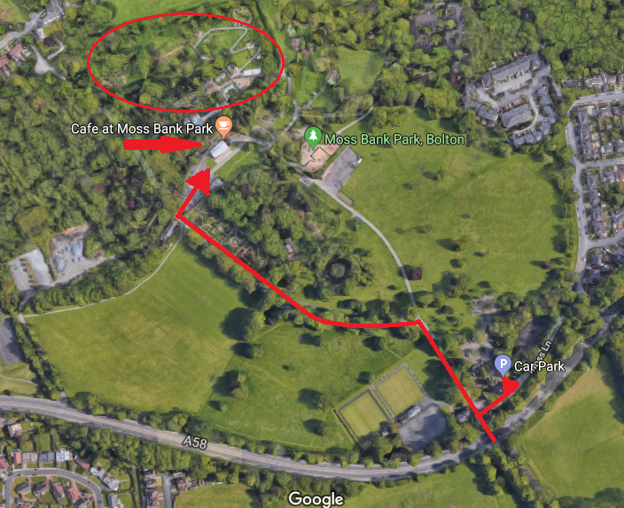
WHAT TIME DO WE ARRIVE?
Please arrive no earlier than 15mins before your party time slot. The Hive gate won’t be open and the party host will still be getting the final things ready. The host will meet you behind the Cafe 15mins before your party starts.
DO WE NEED TO BRING ANYTHING WITH US?
The only things you need to bring are your party food/utensils/plates/napkins etc along with any completed consent forms. It might be helpful to bring a bin bag to transport the birthday child’s presents.
TOILETS
There are no toilet facilities on the Hive, instead the party guests should use the public park toilets that are near the entrance to the Hive at the side of the café.
ACCESS
There is access for prams are wheelchairs across the HIVE.
IS THE PARTY CATERED?
No. We don’t cater for parties, so you are free to bring whatever food you fancy! Do get in touch if you have any questions regarding food options. If you want to have hotdogs at your party please confirm in advance and supply everything you will need for them including, bread sauces, knife to cut the bread, tin openers etc. We will build the fire and the pans to heat the hot dogs in.
PLASTIC AND PACKAGING
We are an environmental charity we strongly encourage recycling and would appreciate it if you could take all unrecyclable waste home to dispose of and where possible minimise the amount of single use plastic you bring to the site.
WHAT KIND OF FOOD SHOULD WE BRING?
That’s up to you. We have had all sorts of party food in the past, so feel free to ask us. Bear in mind we eat outside, with minimal catering facilities, so you wouldn’t want to bring lot of bits.
WHAT SHOULD WE WEAR?
We pride ourselves on the unique nature of our parties – an immersive outdoor experience – and as such we enjoy spending our whole time outside. Therefore, you should dress appropriately for being outdoors and for the weather. We always recommend waterproof shoes or wellies. We love to see the children in fancy dress, but it needs to be practical and suitable for outdoor activity and adventures. To ensure that all your guests are able to enjoy the party please make sure they know in advance that the party is FULLY OUTDOORS so they can make sure any adults and children attending come prepared for all weathers.
WHAT DO WE DO IF THE WEATHER IS BAD?
We would only cancel or postpone a party if the weather presented a health and safety risk, for example in high winds or thunderstorms. That decision would be made by Lancashire Wildlife Trust staff as soon as possible to minimise disruption or disappointment and we’d contact you as soon as we could to talk to you.
IS THERE INDOOR SPACE AVAILABLE, IN CASE IT RAINS?
We do have a secure indoor space for belongings plus we have an outdoor space that is under canvas that we use for some of our activities and for eating. The rest of the time we’ll be out enjoying the weather!
ARE DOGS ALLOWED?
No, sorry the Hive is a dog free zone.
IS SMOKING ALLOWED ONSITE?
It is a no smoking site and all cigarettes and vapours are not permitted.
CAN WE HAVE MORE THAN 20 CHILDREN?
Sorry, for health and safety reasons we have to limit the party size to 20.
WASTE FROM PARTY FOOD
Need to bring anything - maybe could include bin liners?
WHAT’S INCLUDED IN A WILD PARTY?
You will have a minimum of one dedicated party host to deliver a range of games and activities to the children. The host is will be an experienced Lancashire Wildlife Trust officer and their job will be to lead the games throughout the session. There will be 1 hour and 40 minutes of scheduled activities with a 20-minute slot at the end of the session for party food.
HOW DO I PAY?
We charge a flat fee of £200 for all our parties. After we receive confirmation that you wish to proceed with the party we’ll email out an online payment link which needs to be settled in full four weeks prior to the party or as soon as possible with late bookings.

