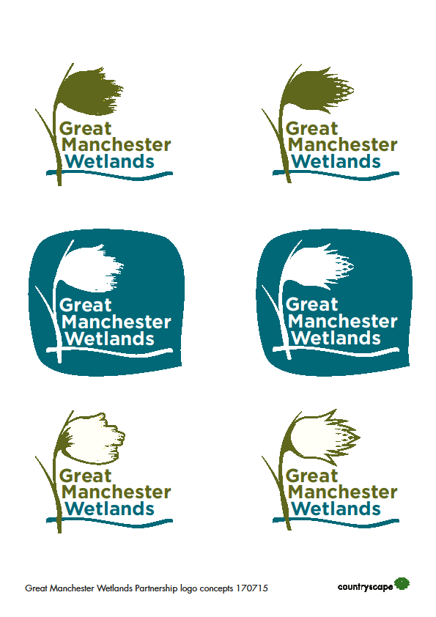

Great Manchester Wetlands NIA Partnership
BRIEFING NOTE

- Who are we?
We are a partnership of local authorities, statutory organisations, businesses, academic institutions, environmental charities and community groups who have been working together since 2011 to deliver improvements to nature and wildlife for the benefit of local communities. Great Manchester Wetlands is a locally determined Nature Improvement Area (NIA) (designated in 2013 by the Local Nature Partnership). A full list of organisations involved in the Partnership can be found in Annex A.

- Where do we operate?
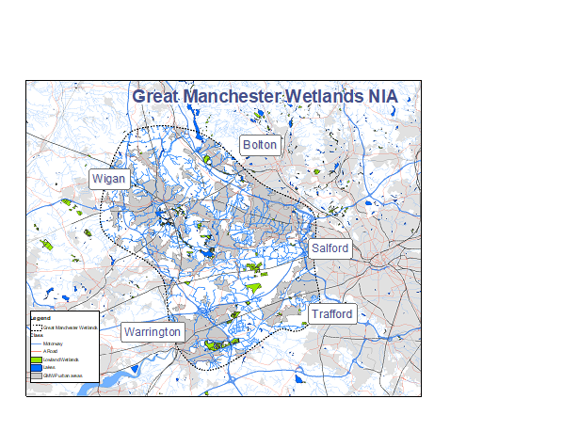
The Great Manchester Wetlands (GM Wetlands) is a 185-square mile (48,000 hectares) Nature Improvement Area. We focus on the wetland areas of the Flashes of Wigan and Leigh, the Mosslands of Wigan, Salford and Warrington and the Mersey Wetlands corridor including Rixton and Woolston Eyes in Warrington. Our area extends south-eastwards beyond the Manchester Ship Canal encompassing parts of Trafford, including the peatlands of Carrington Moss, and northwards to include a substantial corridor which is the watershed area between the Mersey and the River Douglas catchments, including parts of Bolton. Whilst the area includes many valuable wildlife sites, the surrounding communities are often in areas of high social deprivation.

- What are we aiming to achieve?
In December 2025, following a review earlier in the year, the Partnership agreed an update to the vision of GM Wetlands:
By 2040 Great Manchester Wetlands will be an even richer, more resilient and inspirational landscape adapting to environmental change, with effective nature connectivity, continuing to deliver real benefits to local communities and the economy.
Our detailed objectives are to:
1. Improve connectivity for species across the Great Manchester Wetlands landscape by creating and enhancing a nature recovery network that helps wildlife adapt to future pressures.
2. Make lasting improvements to characteristic and nationally rare wildlife by restoring key sites and priority habitats in Great Manchester Wetlands.
3. Optimise the natural capital of the landscape’s habitats and realise the wider benefits they provide such as carbon storage, flood risk reduction and better water and air quality.
4. Continue to build and deliver a shared vision for nature recovery in the wider landscape with key partners, organisations and local people.
5. Enhance community health, wellbeing, learning and skills through improved connection with, and access to, nature and creative engagement with the landscape and its heritage.

- What have we achieved so far?
GM Wetlands has been very successful since its inception. Key achievements are:
- The National Nature Reserve declaration in 2022 for the Flashes of Wigan and Leigh, covering 800 ha​.
- The National Nature Reserve declaration in 2025 for the Risley, Holcroft and Chat Moss Kings Series covering 556 ha.​
- Around £25 million of delivery for wildlife and people. ​
- The demonstration of nature-based solutions and supporting research e.g. wetter farming trials on peat to achieve carbon emissions reduction and more sustainable products, large-scale natural flood management schemes; peatland restoration and connectivity; and measuring reductions in greenhouse gas emissions from species-rich grasslands​.
- The development of Green Finance products e.g. Biodiversity Net Gain units at Cutacre Nature Reserve and in Wigan Greenheart; Wilder Carbon units at Turf Nest Farm.
- The reintroduction of lost species starting with the Manchester Argus butterfly and rare mossland plants, and support for threatened flagship species such as the willow tit and bittern.​
- The Wigan Greenheart Landscape Recovery Scheme included in the first round of pilot 20 year blended public and private nature recovery projects. ​
- The delivery of a three year landowner engagement and demonstration programme.
- The 5-year Carbon Landscape project which improved 776 ha of land across Wigan, Warrington and Salford, engaged 14,162 people, trained 2792 people, and worked with 1500 volunteers and 112 community groups between 2017 and 2022.
- The recognition and inclusion of the NIA and its aims in regional strategies and plans including the Local Nature Recovery Strategies. ​
- Committed group of active partners working on nature recovery delivery, influencing, engagement, research, demonstration, policies and plans​.
- What more will we do and why?
The aim of the Partnership is to deliver a nature recovery network between the heavily urbanised areas of Greater Manchester, Warrington and Merseyside.
Four Local Nature Recovery Strategies (Greater Manchester, Cheshire and Warrington, Lancashire and Liverpool City Region) have mapped nature networks – current and potential habitat corridors that allow wildlife to move, to respond to pressures and thrive – that cross or link into GM Wetlands’ area.
We will use these strategies to inform and build on our partnership activity, identifying priorities and opportunities for wetland habitat network creation and restoration, helping to support species, and improve and buffer core sites, and link up sites via corridors or stepping stones.
This work is important to continue in the face of the twin climate and biodiversity crises, continuing pressure on the natural environment from increasing populations, housing, transport and infrastructure development, fragmentation and disconnection of nature networks, and reductions in protections and governmental ambitions around nature, despite the increasing evidence of nature’s value to societies’ health, wellbeing, culture and economy and its ability to mitigate climate impacts.
We want GM Wetlands to become an exemplar of biodiversity restoration and enhancement that helps connect people to the nature on their doorsteps, encourages communities, land managers, policy makers and other stakeholders to get involved in making the landscape more resilient, deriving long term societal and economic benefit, and that helps species to survive and thrive in the face of pressures.

- How will we deliver improvement?
The partnership’s former strategic plan is at the point of update. We have developed a method of prioritising future delivery options to create a project pipeline, for which we will seek implementation mechanisms. These might include:
- Securing grant funding
- Selling green finance products
- Securing corporate partnership funding
- Developing further ELMS projects
- Working with and influencing wider landowners
- Development and delivery of National Nature Reserve plans
- Sharing learning and innovation
- Working in partnership with others

Annex A. Organisations involved in GM Wetlands:

NGOs/Charities/Community Groups

- Cheshire Wildlife Trust
- City of Trees
- Lancashire Wildlife Trust (Lead Partner)
- Mersey Rivers Trust
- RSPB
- The Conservation Volunteers
- Woolston Eyes Conservation Group

Local Authorities

- Greater Manchester Ecology Unit
- Salford City Council
- Trafford Council
- Warrington Borough Council
- Wigan Council

Statutory Organisations

- Environment Agency
- Forestry England
- Natural England

Businesses

- Peel Land

Academic Institutions

- University of Manchester
- Manchester Metropolitan University

Other non-partner organisations are also able to be involved directly in specific project delivery.

