Great Manchester Wetlands Terms of Reference v 2.0

Review Date: 31st December 2026 Lead: Jo Kennedy

Amendment History

Version / Issue No. | Date | Author | Remarks / Reason for Change
Version 1.0 | 19th October 2021 | J Kennedy | Terms of Reference for GM Wetlands Partnership
Draft 1.1 | 16th December 2024 | J Kennedy | Update to vision date, added Status, Meetings and Data Sharing sections and included role of Chair and Amendment History. For review by Partnership.
Version 1.1 | 20th March 2025 | J Kennedy | Amends approved by partners
Version 2.0 | 18th December 2025 | J Kennedy | Updated with approved 2040 Vision and Objectives as agreed at partnership meeting 10.12.25

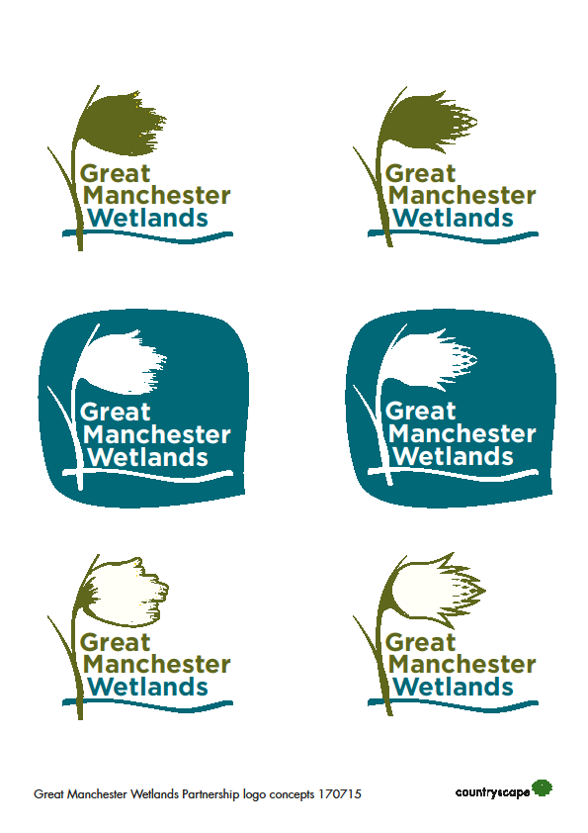

Great Manchester Wetlands Nature Improvement Area PARTNERSHIP TERMS OF REFERENCE

- Scope

Great Manchester Wetlands Partnership is the supporting body for the Great Manchester Wetlands Nature Improvement Area (NIA). The Partnership was established in 2011. The NIA was locally determined by the Greater Manchester and Cheshire Local Nature Partnerships in 2013. A map showing the boundary of the Great Manchester Wetlands geographic area can be found in Annex 1.
- Purpose

The Great Manchester Wetlands Partnership exists to work together to progress the objectives and aims of the Great Manchester Wetlands NIA (sometimes referred to as GM Wetlands).
Our vision is that:
- By 2040 Great Manchester Wetlands will be an even richer, more resilient and inspirational landscape adapting to environmental change, with effective nature connectivity, continuing to deliver real benefits to local communities and the economy
Our detailed objectives are to:
1. Improve connectivity for species across the Great Manchester Wetlands landscape by creating and enhancing a nature recovery network that helps wildlife adapt to future pressures.
2. Make lasting improvements to characteristic and nationally rare wildlife by restoring key sites and priority habitats in Great Manchester Wetlands.
3. Optimise the natural capital of the landscape’s habitats and realise the wider benefits they provide such as carbon storage, flood risk reduction and better water and air quality.
4. Continue to build and deliver a shared vision for nature recovery in the wider landscape with key partners, organisations and local people.
5. Enhance community health, wellbeing, learning and skills through improved connection with, and access to, nature and creative engagement with the landscape and its heritage.
- Status

GM Wetlands Partnership is a voluntary, non-statutory body. It is unincorporated and not a legal entity. The Partnership does not hold or expend funds itself. Projects and activities recommended or supported by the Partnership will be led by member (or other) organisations best placed to do so.

- Membership
Membership of the Partnership is open to relevant local authorities, statutory bodies, businesses, NGOs, charities, community groups, academic institutions or other bodies who are willing and able to commit to and contribute to the long term aims and development of the Partnership. A lead partner will be assigned to be responsible for Partnership coordination. Non-members may be invited to meetings from time to time.

A current list of organisations involved can be found in Annex 2.
- Coordinator and Chair roles

The Partnership will be supported, to the extent that resource is available, by a Coordinator role, hosted by the Lead Partner, who will organise meetings, share information, support the website and other communications and maintain the strategic plan. A Chair will be appointed by members for the purposes of running effective partnership meetings.
- Meetings

Meetings will generally be held quarterly at dates and times agreed in advance. The format of the meeting will allow for knowledge sharing, discussion and building cooperation and common purpose between members. The format may be in person meetings, walk and talk site visits or online meetings. The Partnership Coordinator will ensure agendas, minutes and papers are shared in a timely manner.
- Member commitments

Members commit to:
- Meeting on a quarterly basis
- Sharing relevant information and knowledge with others in the partnership
- Promoting GM Wetlands in their own work and communications
- Taking into account the aims of GM Wetlands in policies, strategies, plans and projects
- Supporting joint funding bids and delivery projects
- Influencing others to support the delivery of GM Wetlands’ aims
- Working and communicating with each other effectively and cooperatively

- Methods of working/means of contributing
Members of the partnership will work together collaboratively in the spirit of mutual support to deliver improvements. Ways in which members can contribute more widely to GM Wetlands include:
  - using strategic influence to support GM Wetlands
  - communicating GM Wetlands activities more widely
  - helping steer the long-term strategy and direction and ensuring GM Wetlands responds to changes
  - identifying opportunities and threats
  - providing information and direction for work streams
  - undertaking research and applying latest techniques/tools
  - sharing specialist knowledge or the benefit of experience
  - providing advice
  - disseminating best practice
  - ensuring work adheres to relevant standards and guidelines
  - taking an overview of delivery work to ensure it is integrated
  - monitoring and recording outputs.

- Data Sharing

By joining the GM Wetlands distribution list, members agree to have their email addresses stored and shared with and between other Partners, for the purpose of enabling collaboration. To opt out of sharing, members must request this in writing from the Partnership Coordinator.

Annex 1: Where do we operate?
The Great Manchester Wetlands (GM Wetlands) is a 185-square mile (48,000 hectares) Nature Improvement Area. We focus on the wetland areas of the Flashes of Wigan and Leigh, the Mosslands of Wigan, Salford and Warrington and the Mersey Wetlands corridor including Rixton and Woolston Eyes in Warrington. Our area extends south-eastwards beyond the Manchester Ship Canal encompassing parts of Trafford, including the peatlands of Carrington Moss, and northwards to include a substantial corridor which is the watershed area between the Mersey and the River Douglas catchments, including parts of Bolton.

Annex 2: Organisations who are currently involved:

NGOs/Charities/Community Groups

- Cheshire Wildlife Trust
- City of Trees
- Lancashire Wildlife Trust (Lead Partner)
- Mersey Rivers Trust
- RSPB
- The Conservation Volunteers
- The Woodland Trust
- Woolston Eyes Conservation Group

Local Authorities

- Greater Manchester Ecology Unit
- Salford City Council
- Trafford Council
- Warrington Borough Council
- Wigan Council

Statutory Organisations

- Environment Agency
- Forestry England
- Natural England

Businesses

- Peel Land

Academic Institutions

- Manchester Metropolitan University
- University of Manchester

Other non-partner organisations may be involved in specific delivery projects.

